

|  |
| --- |
| Photo displaying partial image of two pie charts on a canvas-textured page |
| Amazon Sales Report  Innobyte Services Data Analyst Internship Project |
| |  |  |  | | --- | --- | --- | | Created by: Divya Pardeshi |  | 9/20/24 | |

**Problem Statement:**

Analyze and Provide Insights on Amazon Sales Report

**Problem Description:**

The provided dataset contains information about sales transactions on Amazon, including details such as order ID, date, status, fulfilment method, sales channel, product category, size, quantity, amount, shipping details, and more. The objective is to conduct a comprehensive analysis of the data and extract actionable insights to support business decision-making.

1. **Sales Overview**

* **Analyze Monthly Sales Trend**

**Key Insights:**

* The average monthly sales have fluctuated over the period.
* There was a decline in average sales from March to April, followed by a significant increase from May to June.

**Key Insights:**

* The total sales increased dramatically from March to April, reaching a peak in April. This substantial growth could be attributed to various factors, such as promotional activities, seasonal demand, or changes in product offerings.

**Key Insights**

* The order count reached its peak in April, indicating the highest demand activity during this month.
* In contrast, March saw the lowest order count, suggesting minimal demand or sales compared to the other months.

**Key Insights:**

* A significant jump in Average Order Value (AOV) was observed from April to May and then again, a jump in June. This suggests that customers were purchasing larger quantities or higher-priced items during this period.
* The overall trend suggests an increase in AOV over the four-month period. This indicates a positive development for the business, as customers are spending more per order on average.

**Key Insights:**

* March had the highest cancellation rate despite having the lowest order count and total sales, suggesting a potential issue with order fulfillment or customer satisfaction during this month.

**II. Product Analysis**

* **Analyze Product Category Distribution**

**Key Insights:**

**Dominant Categories:** T-shirts lead sales, followed by shirts and blazers, contributing significantly to total revenue.

**Underperforming Categories**: Other categories show relatively low sales, warranting further strategic focus.

* **Analyze Product Size Distribution**

**Key Insights:**

**Popular Sizes:** Medium (M) is the most sought-after size, followed by Large (L) and Extra-Large (XL).

**Least Popular:** Sizes 4XL and above exhibit minimal demand, suggesting a need to adjust inventory levels accordingly.

* **Quantity Sold Analysis**

**Key Insights:**

**Top-Selling Categories:** T-shirts, shirts, and blazers not only generate high revenue but also have substantial quantities sold.

**Size-wise Quantity:** Aligns with sales data, with Medium sizes leading in quantity sold.

* **Analyze the distribution of sales across different order statuses**

**Key Insights:**

* Cancelled orders are the dominant order status in terms of total sales, indicating a potential area for improvement.
* The high number of canceled orders might be due to factors such as stock availability issues, incorrect order processing, or customer dissatisfaction.
* Delivered to Buyer order status represents a significant portion of the sales, indicating successful order fulfillment and delivery.
* Analyzing the reasons behind canceled orders can help identify opportunities to improve order fulfillment and reduce cancellations.

**III. Fulfillment Analysis**

* **Analyze fulfillment Methods**

* Amazon fulfillment method generated significantly higher total sales compared to Merchant fulfillment, indicating that it is the preferred choice for most customers.
* Merchant fulfillment accounted for a relatively small portion of the total sales, suggesting that it may not be as widely used or effective compared to Amazon fulfillment.
* **Examine the proportion of Standard vs. Expedited shipping service levels**

**Expedited Shipping:** Preferred by 68.9% of orders, reflecting customer desire for faster delivery.

**Standard Shipping**: Utilized in 31.1% of orders, indicating a willingness to pay for expedited services.

* **Analyze the proportion of different courier statuses (e.g., Shipped, Cancelled, On the Way) to assess the overall efficiency of the delivery process.**

* The vast majority of orders (84.9%) have been shipped successfully, indicating a high level of order fulfillment efficiency.
* However, a small percentage of orders are still unshipped or cancelled, suggesting areas for improvement in the order processing and delivery process.
* **Analyze how different shipping service levels (Standard vs. Expedited) influence courier statuses.**

* Expedited shipping appears to be a more reliable and efficient service level, with a lower rate of issues and faster delivery times.
* Standard shipping may need to be reevaluated to address the higher rate of “On the Way” and “unshipped” orders. Improvements in order processing, inventory management, or carrier selection could help mitigate these issues.
* **Analyze temporal trends in courier statuses to detect recurring issues or improvements in delivery processes**

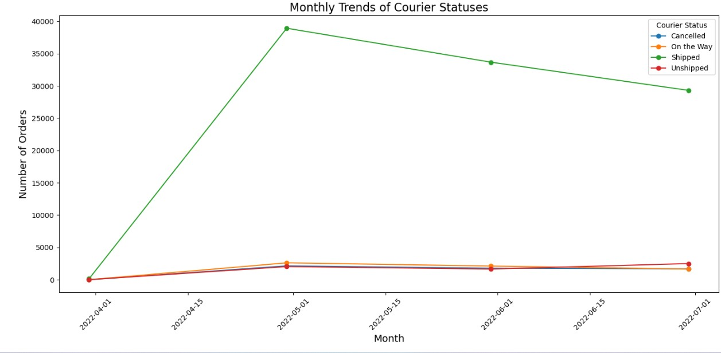

* The overall trend for shipped orders is positive, indicating improved order fulfillment and delivery efficiency. However, there are still issues with canceled and unshipped orders that need to be addressed to enhance customer satisfaction.
* **Analyze how different fulfillment methods affect courier statuses, such as cancellation rates or shipping delays.**

The above heatmap provides a visual representation of the relationship between fulfillment method (Amazon or Merchant) and courier status (Cancelled, On the Way, Shipped, or Unshipped).

* Orders fulfilled by Amazon have a significantly higher percentage of successful shipments (86.5%) compared to Merchant fulfillment(81.1%).
* Cancellation rates for Amazon orders (6.7%) which is high compared to Merchant orders (0%).
* Only a small percentage (1.3%) of Merchant orders are "Unshipped."
* A significant portion of Merchant orders approximately (17.6 %) are still "On the Way," indicating potential delays.

**IV. Customer Segmentation**

* **Analyze sales performance using Sales Channel**

**Amazon.in Dominance:** Significantly higher total sales compared to Non-Amazon channels, emphasizing the platform's central role in sales.

* **Categorize customers into segments (e.g., B2B vs. B2C) and analyze sales performance.**

* B2B sales are the dominant customer type, indicating that the business primarily focuses on selling to other businesses.
* B2C sales are relatively low, suggesting that the business may need to explore strategies to increase its market share in the consumer market.

**V. Geographical Analysis**

* **Visualize total sales across different states to identify top-performing States**

* Maharashtra leads the sales figures with over 12 million in total sales, emerging as the top-performing state.
* It is followed by Karnataka and Uttar Pradesh, indicating strong market penetration in these regions.
* The significant contribution from Maharashtra suggests that it could be a critical market for future growth strategies, while Karnataka and Uttar Pradesh also show promising opportunities for further expansion.
* **Visualize total sales across different states to identify top-performing Cities**

**Leading Cities:** Bangalore tops with over INR 6 million in sales, followed by Hyderabad and Mumbai.

**Growth Opportunities:** Focused marketing in Bangalore, Hyderabad, and Mumbai can further capitalize on existing sales momentum.

* **Examine how courier statuses vary across different states, identifying regions with higher cancellation rates or delivery issues.**

* Maharashtra and Karnataka have high success rates in order fulfillment and delivery, with low cancellation and unshipped rates.
* Other states exhibit varying levels of performance, with some having higher rates of cancelled or unshipped orders.

**Business Insights & Recommendations**

1. **Enhance Fulfillment Operations:**
2. *Investigate High Cancellations in Amazon Fulfillment:* Analyze reasons behind the 6.7% cancellation rate to improve order reliability.
3. *Optimize Merchant Fulfillment:* Address delays in Merchant Fulfillment to enhance customer satisfaction and reduce the "On the Way" status.
4. **Expand B2C Market Share:**
5. *Targeted Marketing Campaigns:* Develop strategies to attract and retain B2C customers, potentially increasing overall sales.
6. *Product Diversification:* Introduce products tailored to consumer preferences to boost B2C appeal.
7. **Inventory Management:**
8. *Adjust Stock Levels Based on Size Demand:* Reduce inventory for less popular sizes (e.g., 4XL) and increase for high-demand sizes (e.g., M, L, XL).
9. *Focus on Top-Selling Categories:* Allocate more resources to T-shirts, shirts, and blazers to maximize revenue.
10. **Geographical Expansion Strategies:**
11. *Leverage High-Performing Markets:* Invest in marketing and infrastructure in Maharashtra, Karnataka, and Uttar Pradesh to sustain and grow sales.
12. *Address Regional Fulfillment Issues:* Implement localized solutions in states with higher cancellation rates to improve delivery performance.
13. **Optimize Shipping Service Offerings:**
14. *Promote Expedited Shipping:* Given its popularity, consider incentivizing customers to choose expedited shipping through discounts or loyalty rewards.
15. *Improve Standard Shipping Reliability:* Enhance the reliability and speed of standard shipping to cater to cost-sensitive customers.
16. **Customer Satisfaction Initiatives:**
17. *Analyze and Mitigate Cancellation Causes:* Conduct root cause analysis on order cancellations to address fulfillment or product issues.
18. *Enhance Customer Support:* Provide better support for delayed or canceled orders to maintain trust and loyalty.

**Conclusion:**

The comprehensive analysis of Amazon's sales data underscores the platform's strong performance in specific product categories, fulfillment methods, and geographical markets. While B2B sales and Amazon Fulfillment dominate, there are clear opportunities to expand into the B2C segment and improve fulfillment efficiency across all methods. Strategic focus on high-performing markets, coupled with targeted marketing and operational optimizations, can drive sustained growth and enhanced customer satisfaction.